**Project Design Phase-II**

**Data Flow Diagram & User Stories**

|  |  |
| --- | --- |
| Date | 03 October 2022 |
| Team ID | PNT2022TMID34602 |
| Project Name | Project – Early Detection of Chronic Kidney Disease using Machine Learning |
| Maximum Marks | 4 Marks |

**Data Flow Diagrams:**

A Data Flow Diagram (DFD) is a traditional visual representation of the information flows within a system. A neat and clear DFD can depict the right amount of the system requirement graphically. It shows how data enters and leaves the system, what changes the information, and where data is store.

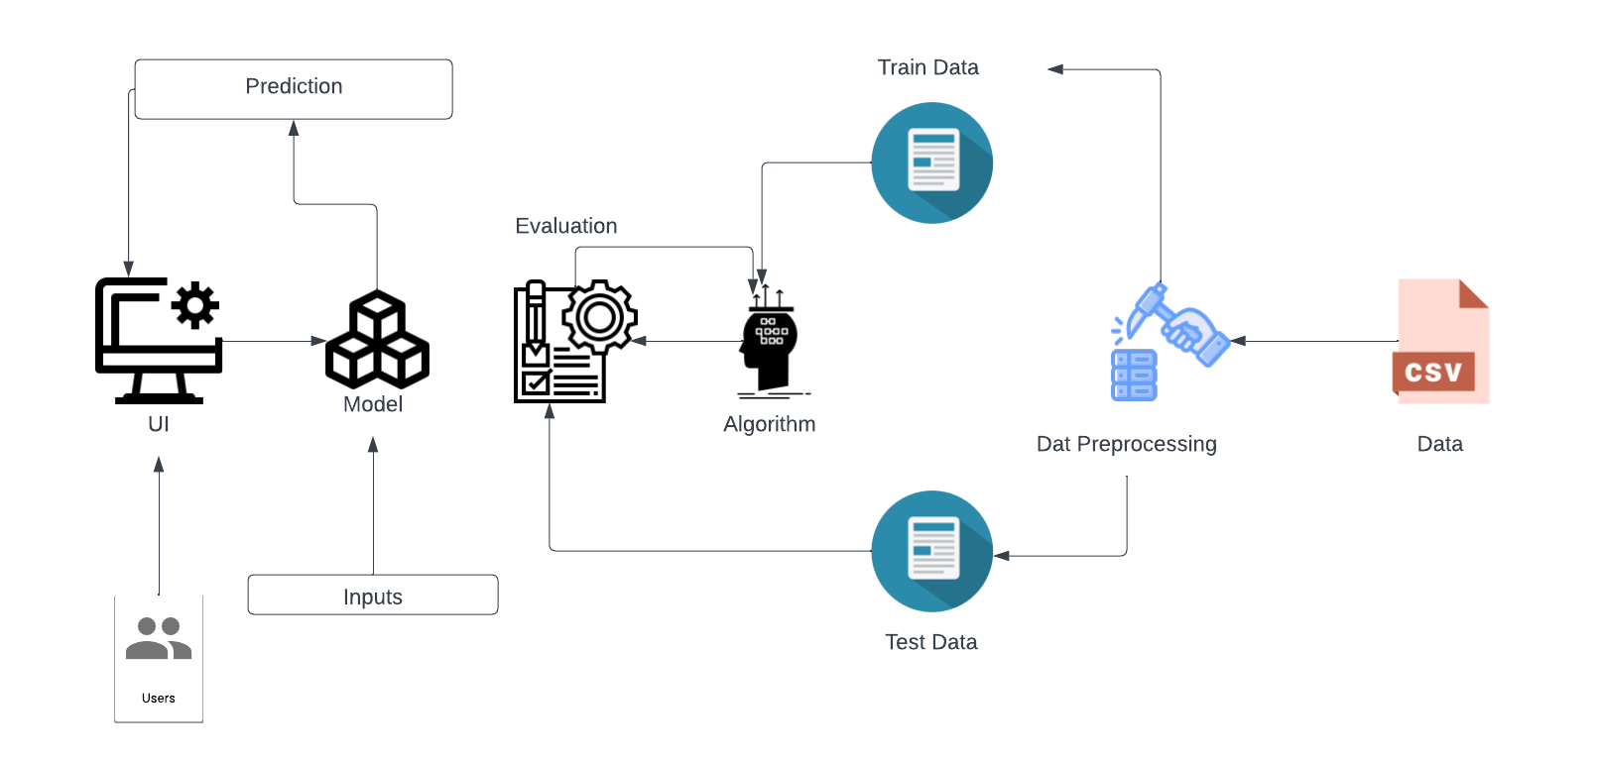\

**User Stories**

Use the below template to list all the user stories for the product.

| **User Type** | **Functional Requirement (Epic)** | **User Story Number** | **User Story / Task** | **Acceptance criteria** | **Priority** | **Release** |
| --- | --- | --- | --- | --- | --- | --- |
| Customer (web user) | Dashboard | USN-1 | As a user, I can directly access the dashboard of the website inorder to know about kidney disease | I can access my dashboard | High | Sprint-1 |
|  |  | USN-2 | As a user, I can learn about what doctors think about kidney disease | I can access the dashboard | Low | Sprint-2 |
| Administrator | Superuser | USN-1 | As a administrator , I would want my application to be accurate in order to predict the kidney disease. | I must ensure the correct of the website | High | Sprint-3 |
|  |  | USN-2 | As a administrator , I want my website to run smoothly without any error. | I must ensure that my application run without any error | High | Sprint-3 |
| Team Members(Developers) | Developer tools | USN-1 | As a Developer , I want the website to be interactive and must satisfy the user . | I must ensure that the website is interactive | Medium | Sprint-4 |
|  |  | USN-2 | As a Developer , I want my website to be free of bugs and other internal crashes | I must ensure that the website must be free from bugs | High | Sprint-4 |
|  |  | USN-3 | As a Developer, I must ensure that the project works fine by using the dataset provided | I should use the correct dataset to predict the disease | High | Sprint-2 |
|  |  |  |  |  |  |  |
|  |  |  |  |  |  |  |